Shanley Philip
Doug Welch
CSCI 598D ML
Assignment 4
Reinforcement Learning

Our task was to implement a Q learning function on a computer and have the computer determine the proper corrective movement in order to balance a pole over a cart. A given episode is a failure if a pole is perpendicular to the vertical. In the simplest case, physics are not a concern and the learning machine is only given the current location of the cart on a track, and the angle (with respect to the vertical) of the pole.

Initially, the Q learning table is set to zero where as the immediate rewards table is set to zero except the table entries representing the stable positions (anywhere on the track with an angle of zero). Every entry in both tables represents every possible combination of cart position and pole orientation. During each trial, the program uses a path to determine the effects of the selected action. This path is a randomly generated set of integers to represent the table indices (the x- and y-directions) that correspond to the program’s current location, the destination and the route the program will take. The update function unravels this path and the Q learning table is updated to reflect the rewards earned (from following this path) in hopes of finding an optimal path to travel in order to balance the pole. Each table entry is updated using the following formula:
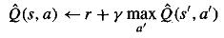
where the approximate Q functions is defined by r (the immediate reward) plus the product of γ (the learning rate, set at 0.9) and the maximum values of the resulting state for all actions taken.
With enough training, a gradient can be formed based on the optimal path to symbolize the amount of force the cart is required to exert on the pole in order to balance the pole.

In both the rewards table and the q-learning table use the following convention. A pole with an angle of zero is defined as the stable position, the angle that the pole is considered to be balanced. If the pole falls toward the right side, this angle is positive and the opposite is true as the pole falls toward the left side (negative angle). A cart sitting in the middle of track is said to have a position of zero. As the cart moves to the right, the position increases in the positive direction. On the other hand, movements to the left correspond to the increase of position in the negative direction. The result is that a table can be constructed to represent these physical constructs, as shown below.

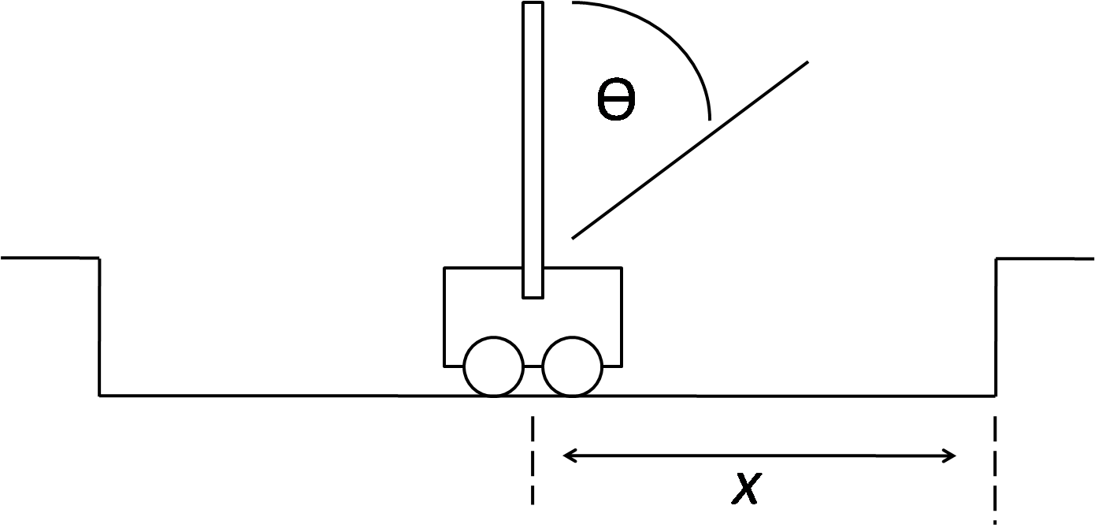
Figure 1: An illustration of the pole-balancing problem and the notation used

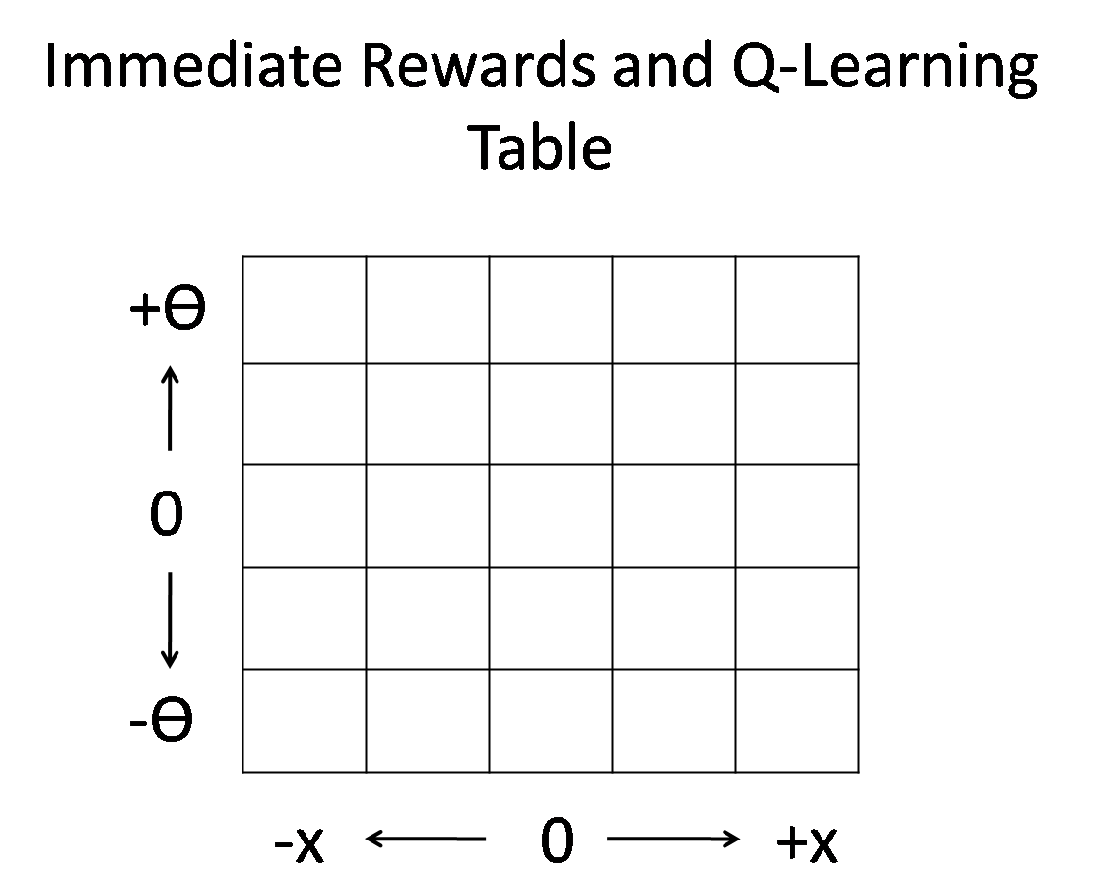
Figure 2: An illustration of how Figure 1 can be represented using a table

Results (next page)
We found that increasing the resolution of pole angles and cart positions caused the Q-learning algorithms to take more trials to converge. Also the length of the random path played a huge role.

